Resources on Asian and Pacific Island Catholics from the United States Conference of Catholic Bishops (USCCB)

Get your copy by contacting scapa@usccb.org. $4/copy, check pay to: Asian and Pacific Island Affairs. The USCCB Subcommittee on Asian and Pacific Island Affairs is actively working on having more books on other Asian and Pacific

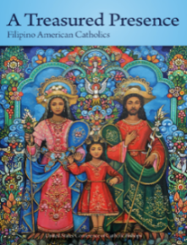
A Treasured Presence: Filipino American Catholics

Pick up this quick weekend read, and learn about the history, blessing, and promise of Filipino Catholics in the United States! Delve into this book to see the dynamics of how the inculturation of Catholicism in the Philippines and the growth of the Filipino population in the United States has become a multi-faceted story of encounter, immigration, family, tradition, and faith.

